Chicago’s Fabulous Fountains
By Greg Borzo

Chicago Cycling Club

Sun., July 9, 2017; 9:00 am–11:30ish
Greg Borzo: 312-636-8968

Start at fountain at the
Chicago History Museum

E thru Lincoln Park
NW thru Lincoln Park
N on Stockton
W on Belden
S on Clark
W on Wisconsin
S on Hudson
E on Menomonee
S on Wells
E on Burton
S on Clark
SE thru Washington Square Park
E on Delaware
N on State
S on State
E on Delaware
S on Michigan
E on Chicago
S on Fairbanks
E on Ohio
S on McClurg

End along the Chicago River
Coffee? Tea? Beer? Food?

Children’s Fountain

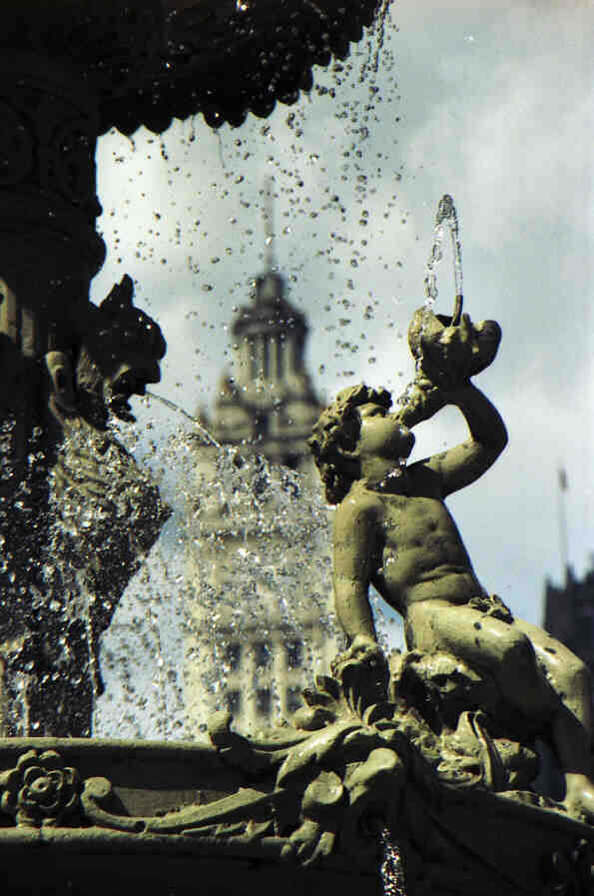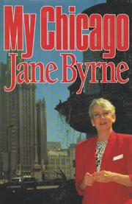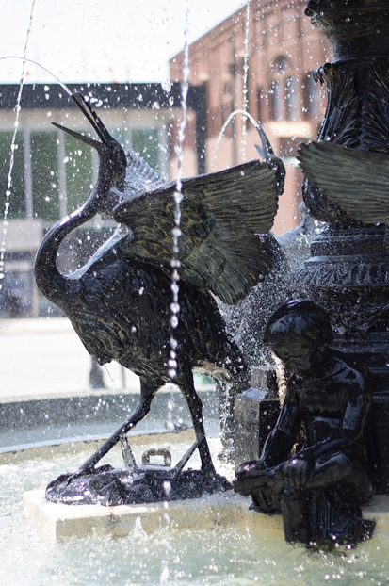
@ Heald Square, 1982-2000 Cover of Byrne’s memoir @ CHM, 2005-today

Other highlights

